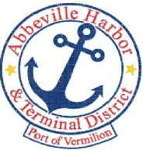
P.O. Box 1410, Abbeville, Louisiana • 70511-1410
Ph: 337-893-9465 e Fax: 337-898-0751 www.abbevilleharbor.com

AGENDA
SPECIAL MEETING
AUGUST 23, 2023

- CALL MEETING TO ORDER – PRESIDENT PATRICK DUHON
- ROLL CALL

- DISCUSS PERSONNEL MATTERS

- ADJOURN

Patrick Duhon, President Carlton Campbell, Commissioner
Jimmie Steen, Vice President Tim Creswell, Commissioner
Bud Zaunbrecher, Secretary-Treasurer James W. Campbell, Executive Director Wayne LeBleu, Commissioner

